**Load the library files for Arduino IDE in MacOS**

**Open the folder where Arduino IDE saves library files**

1. Double click the hard disk

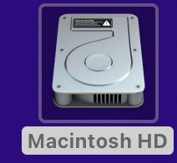

1. User

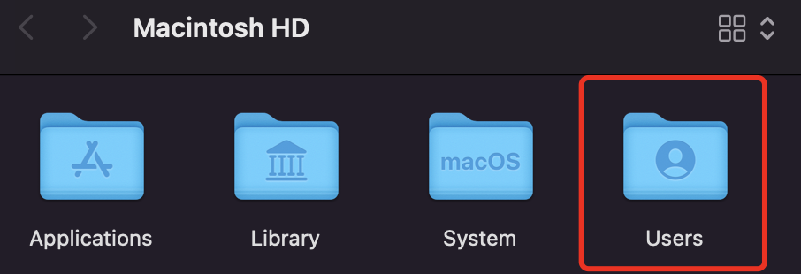

1. Open your User folder

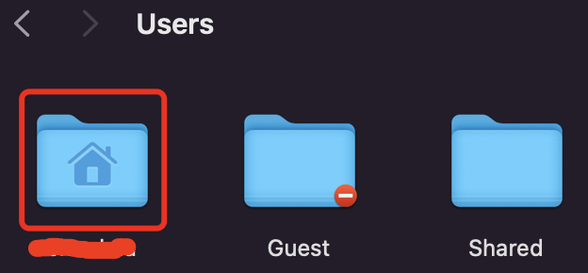

1. Open Document

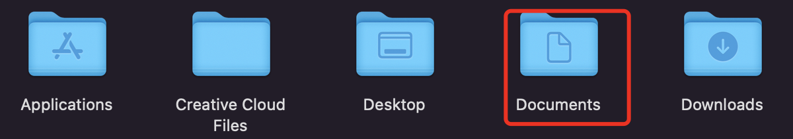

1. Arduino

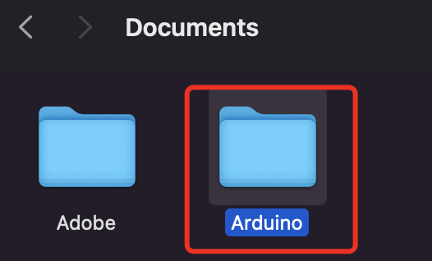

1. Libraries

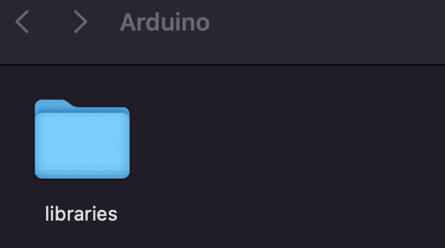

1. Copy the library files provided by us and paste them to the libraries folder above

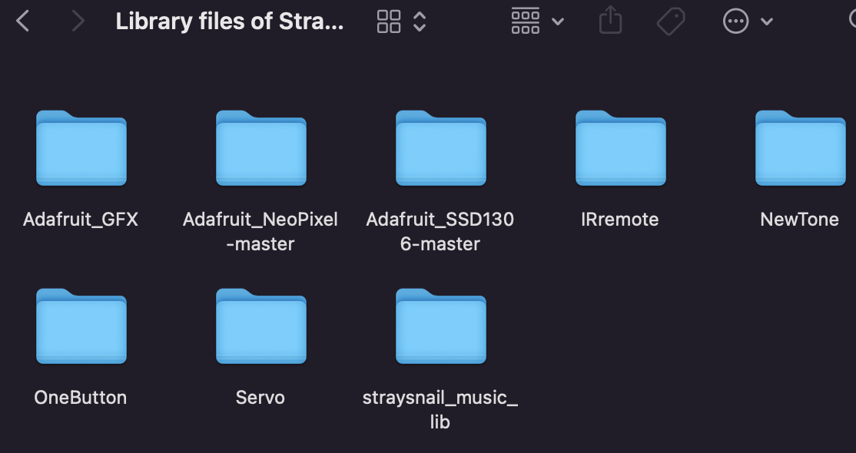

1. Library files loaded successfully

